## Lead Developer: Liam

## Description of Opportunity:

The program will provide a comprehensive list of exercises spanning various muscle groups and fitness goals. Users can easily navigate through the exercise library and select the ones that align with their preferences and target areas. This feature ensures that clients have access to a diverse range of exercises to create a personalised workout routine. The program will also offer tracking capabilities. Users can record their completed workouts, track performance metrics, and view their exercise history. Progress tracking enables clients to stay motivated, measure their achievements, and make informed adjustments to their workout routines as needed.

## Purpose and audience for this SRS:

The purpose of this SRS is to document the detailed requirements of the software system or application and outline the desired functionality, behaviour, and constraints of the system. It provides detailed specifications and guidelines for the lead developers during the design and development phase. Ensures a clear understanding of the project's requirements and minimises the risk of miscommunication or misunderstanding

## Characteristics of the proposed users for the software solution:

The software solution is likely to attract individuals who are passionate about fitness and have a genuine interest in planning and optimising their workout routines. They may have experience with various exercises and fitness principles. The software solution may also cater to individuals who are new to fitness or have limited experience with structured workout routines. These users may require more guidance and assistance in selecting appropriate exercises and creating effective workout schedules.

## Technical description of the environment in which the software solution will operate:

Personal Computers (desktop or laptop) or mobile devices (smartphones or tablets) capable of running the software solution. The software solution should specify the compatible operating systems, such as Windows, and macOS, an internet connection is not required to run the program.

## Functional requirements:

User Registration and Profile Management:

* Allow users to create accounts and register with the software solution.
* Provide options to manage user profiles, including personal information, fitness goals, and workout preferences.

Exercise Library:

* Present a comprehensive library of exercises categorised by muscle groups, fitness goals, or equipment requirements.
* Include exercise descriptions, step-by-step instructions, and images or videos demonstrating proper form.
* Allow users to search, filter, and bookmark exercises for easy access.

Exercise Selection:

* Enable users to select exercises from the library based on their preferences, fitness goals, and target muscle groups.

Progress Tracking:

* Enable users to track their workout progress, including completed exercises, repetitions, weights, and durations.

Workout Schedule Creation:

* Allow users to create and customise their workout schedules based on their availability and preferences. Provide options to specify workout days, durations, repetitions, and rest intervals.

## Non-functional requirements:

Usability:

* Intuitive and visually appealing user interface
* Responsive and fast interactions
* Accessibility support for individuals with disabilities

Reliability:

* Stable operation without frequent crashes or unexpected shutdowns
* Robust error handling and informative error messages
* Data integrity and backup mechanisms

Portability:

* Compatibility with various platforms and operating systems

Robustness:

* Resilience to errors and exceptional scenarios
* Performance under high user loads

Maintainability:

* Clean and modular code for easy maintenance
* Comprehensive documentation for installation and user guides
* Version control for code management
* Scalability for future expansion

## Constraints:

Economic:

* Man hours available to code the program
* Developer costs to maintain/update the program

Legal:

* Ensure compliance with copyright laws and licensing requirements for any third-party resources used, such as exercise videos or images.
* Appropriate measures to protect user data

Technical:

* The software solution should be compatible with a range of operating systems, and devices to accommodate diverse user preferences.
* Deliver a responsive and efficient user experience, with minimal latency and processing delays.

Usability:

* The software solution should have an intuitive and user-friendly interface, enabling users to easily navigate, select exercises, create schedules, and track progress.
* Ensure the software solution is usable by individuals with disabilities, such as providing support for screen readers and keyboard navigation.
* Minimise the learning curve required for users to understand and effectively utilise the features and functionalities of the software solution.

Social:

* Design the solution to be inclusive and considerate of users from various demographics, cultures, and fitness levels.
* supportive and motivating user experience that fosters engagement, encourages progress, and promotes a healthy mindset towards fitness.

## Scope:

User Interface:

* Display a diagram of a person where the user can click on specific body parts to select the corresponding muscle group they want to work out.
* Provide an interactive and user-friendly interface for seamless navigation.

Exercise Selection:

* Offer a comprehensive list of exercises categorized by different body parts.
  + Allow the user to select exercises by clicking on the desired body part.
  + Provide exercise descriptions, instructions, and guidelines to ensure proper form and execution.
  + Optionally, include videos or images demonstrating the correct exercise technique.

Workout Planning:

* + Enable users to create their workout schedules by selecting exercises from the available list.
  + Allow users to customise the duration, intensity, and frequency of their workouts.
  + Provide options to save and name workout routines for future reference.

Completion Tracking:

* + Include a completion feature that allows users to mark exercises or workout sessions as completed.

## Waterfall Model

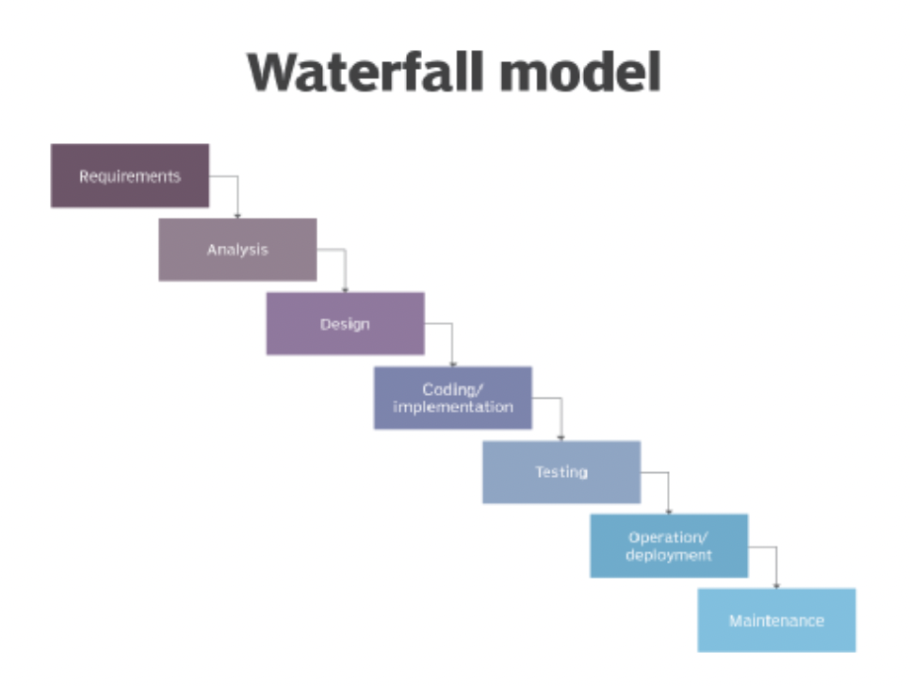

Pros:

* The waterfall model emphasises extensive documentation and planning upfront as you cannot go back and change the previous stages, to promote analysis, design, and specification stages, leading to a comprehensive understanding of the software solution.
* The waterfall model makes it easier to estimate project timelines and deliverables as it is linear. Since each phase is completed before moving on to the next, it allows for better prediction of the project's progress and potential issues.

Cons:

* If requirements are not properly gathered and documented at the beginning, or if changes occur during the development process, the waterfall model can lead to project failure or significant rework.
* The waterfall model lacks flexibility, making it challenging to accommodate changes or new requirements that may arise during the development process.

## Data Collection

What would you want the software to be?

* A workout planner

What features or functionalities are you looking for in a workout planner software?

* Have a completion system to track progress
* View various exercises from a large list of muscle groups
* Be able to create a schedule so users can view exercises for upcoming workouts

Do you have any specific preferences or requirements regarding the user interface and design of the software?

* Yeah, it needs to be easy to understand and simple
* Also need to have calendar to view past and future workouts

How important is it for you to have access to exercise demonstrations through videos or images within the software?

* Not very important, I can get most of the workout information online however images to guide through would be helpful

## Final Design

The Use-Case, Context, and Data Flow (level-1) diagrams, as well as the Data Dictionary, Pseudocode, and Evaluation Criteria, will all be included in my final solution. The 'Mockup 1' specified in the PMI Tables will serve as the GUI's foundation.